**State Dashboard**

**Scheme:**

1. Scheme Section
2. Front Page
3. Transection Section

1. Scheme Section:  
List Page :

**Field Name:**

* Scheme Name (English)
* Scheme Name (Hindi)
* Nodal Department
* Category

Add Page / Detail Page / Edit Page/Delete Page:  
  
**Field Name:**

* Scheme Name (English)
* Scheme Name (Hindi)
* Nodal Department
* Executing Department (Multiple)
* Scheme Description
* Mode of Application [**A**. Online (Emitra, Website(url)) **B**. Offline]
* Category
* Beneficiary Category
* Direct Benefit to Citizen (Yes/No)
* List of Required Documents (Multiple)
* Service Fees (1. Yes(Amount) 2. No)
* Payment Disbursement Mode (Fully, Partially)
* Scheme Output (Financial Assistance, Subsidy, Scholarship, Others)
* Mode of Payment [1. Cash (DBT, Cheque, DD, Cash) 2. Non Cash]
* Mode of Delivery (1. Online through Emitra 2. Postal 3. Physically Collect from office)
* Scheme Type (1. Family 2. Individual 3. Group)
* Eligibility Criteria (Age, Gender, Income, Fees)
* Nodal Officer Detail
* Scheme Area (1. District Level 2. State Level 3. National Level)
* Scheme Delivery Time (In Days)
* Scheme Renewal
* Time of Validity (In Years)
* Scheme Expired on(Date)
* Helpline No.(number)
* FAQ (Question, Answer)
* Act/Rule (Multiple File)
* Citizen Charter (Multiple File)
* Scheme Forms (Multiple File)
* Logo (Image)
* Icon(Image)
* Banner(Image)
* Is Active(True, False)  
  **Note :** Monitoring Parameter need to be discussed.

2. Front Page :  
 **URL** : <http://suraaj.rajasthan.gov.in/hi/annapoorna-rasoi>  
 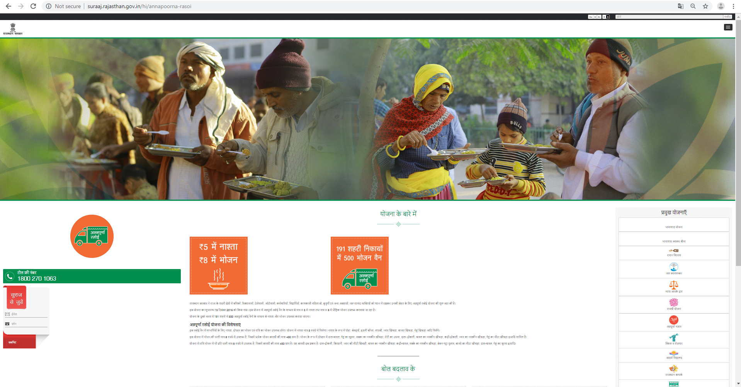

Show data as per above image for public.

3. Transection Screen:

Need to add detail of beneficiary of scheme   
  
 **Note** : Require Entry Form field  
 How user apply for scheme?

**Order** :  
1. Order Section

2. Front Page

1. Order Section  
  
List Page :  
**Field Name:**

* Title
* Order No.
* Remark
* Category

Add Page / Detail Page / Edit Page/Delete Page:

**Field Name:**

* Order No.
* Order Date
* Order Type (Order, Circular, Notification)
* Order Title/Subject
* Order Description
* Sector (Multiple)
* Department (Multiple)
* Beneficiary Category (Multiple)
* Order (with affect from)
* Department Effected (Multiple)
* URL (Reference Link)
* Order Issue by (GOR, GOI)
* Individual Beneficiary Scheme
* Remarks
* Attach Order (Multiple file)
* Is Active(True/false)
* Related To (Multiple)  
  Module   
  Department  
  Year

2 Front Page:  
  
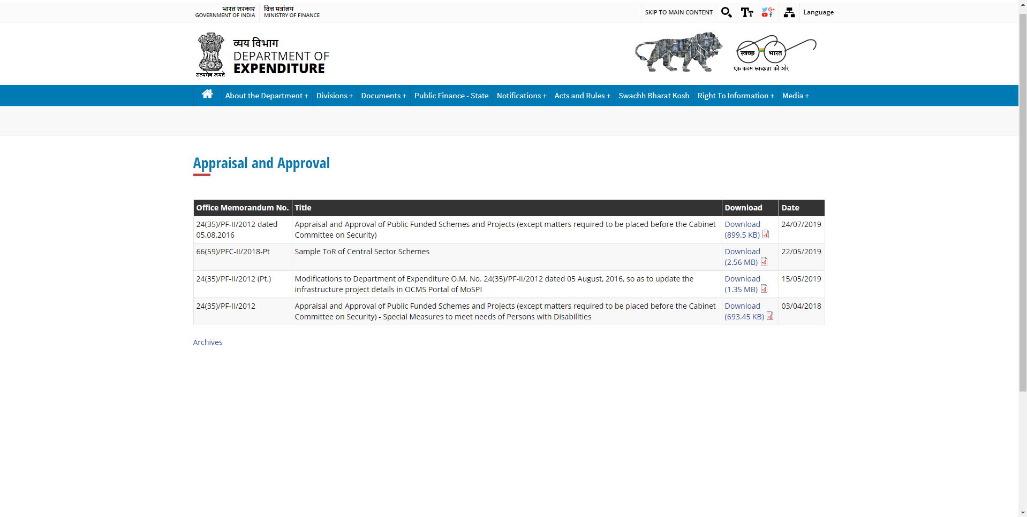  
**Note: A**ny detail page for order section ?

**Advertisement** :

1. Advertisement Section

2. Functionality

1. Advertisement Section  
  
List Page :  
**Field Name:**

* Subject Hindi
* Subject English

Add Page / Detail Page / Edit Page/Delete Page:   
  
**Field Name:**

* Category
* Sub Category
* Subject (English)
* Subject (Hindi)
* Date
* Image for Popup(image)
* Admin Department(Multiple)
* District (Multiple)
* Beneficiary Category(Multiple)
* Is Active(True/False)

2. Functionality:

**Step 1**: Send notification

If “Is Active” field is marked as “true” then send e-mail/sms to selected “Admin Department” to get advertisement from web service and apply on their website  
  
after particular time period resend notification for apply advertisement on their website ,if not apply then resend notification again ,after applying advertisement need to update status to mark as complete .

**Step 2:** Verify request  
If any department try to fetch advertisement then check is they get particular advertisement first time?

If yes, then Provide Data.

If No, then need reason to repeated request.

**Step 3:** Approve Process1.SSO

2. Mail.gov.in

For above mentioned services need to provide download advertisement feature so they can download advertisement and redesign advertisement for approve

after particular time period resend notification for apply advertisement if not apply then resend notification again, after applying advertisement need to update status to mark as complete